Hello Yujin Gakuen families;

Erin’s Law requires that elementary schools share information with students during the year to ensure our students are aware of safe and unsafe touch, and the safe people who they can talk with in their community. Our classroom teachers will be teaching and reviewing safe choices with our students over the next few weeks leading up to the Thanksgiving and Winter break.

Below are web addresses for age-appropriate, Protect Yourself videos that you are welcome to review with your child at home. Included below is a snapshot of the main ideas presented in the videos, which could be displayed in a prominent place in your home.

Also, attached to this email is a link to “Hot Chocolate Talks”, which are age-specific guidelines for talking with kids about preventing sexual abuse.

Hot Chocolate Talks – Parent Resource Guides:
https://www.cfchildren.org/resources/child-abuse-prevention/

Barbara Sinatra videos for grades K-3:
https://www.youtube.com/watch?v=b8R2g5QrDAw

Barbara Sinatra videos for grades 4-6:
https://www.youtube.com/watch?v=RteEiMNIdYo

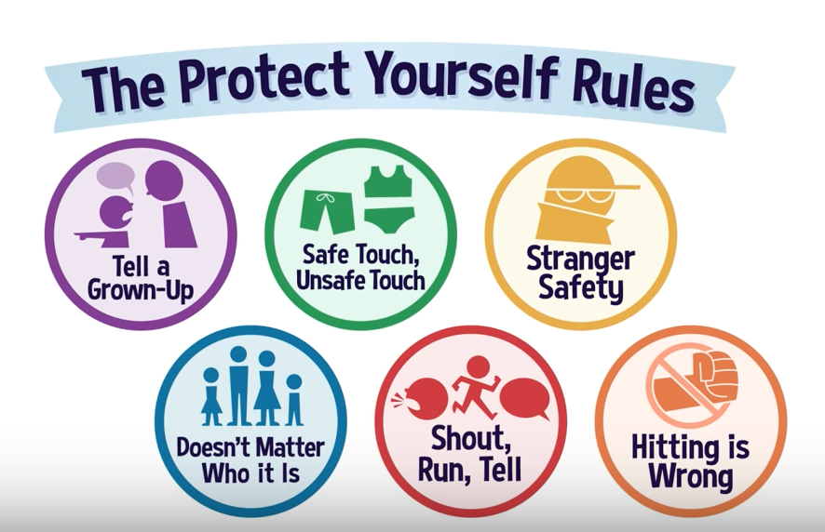

PROTECT YOURSELF RULES
A child abuse and maltreatment prevention and awareness program funded by the Barbara Sinatra Children’s Center Foundation
fightchildabuse.org

Please contact Counselor Scott if you have questions: klein_s@4j.lane.edu, or (541) 933-5669

